20U ENCLOSURE 19" CABINET 600X600 | 20U DATA CABINET FLOOR STANDING
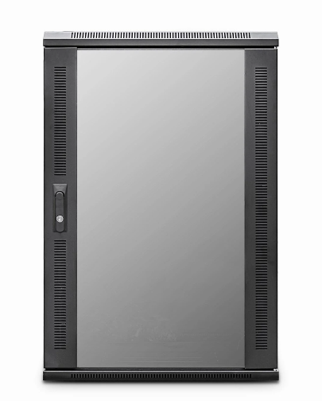

DESCRIPTION
The new CAB-FE-20U-66 20U Data Cabinet Floor Standing is a high-performance, professional class enclosure with an abundance of features to help with both pre and post-installation operations and of course help protect your hardware assets such as generous venting, adjustable front and rear profiles, adjustable jacking feet and HD castors as standard.
As will all LMS Data EcoNetCabs in the series, bundled accessories such as installed fan tray, shelving etc are included as well as excellent ergonomics including front glass door, removable side panels and lockable rear door to house all your equipment effectively.

SPECIFICATIONS
- ETSI 19” front/rear adjustable profiles
- WxDxH - 600x600x1080mm (inc. castors)
- Ideal for Networking, Telco & Broadcast Applications
- Up to 800Kg static load-bearing (approx)
- Front Glass door with side venting slots (lockable)
- Left/right hinged front/rear doors
- Removable side panels for easy access
- U-numbered uprights for rack-mount product alignment
- Multiple cable entry glands for exact power and cabling entry
- Fitted 4-way fan tray in raised and vented roof-space
- Fitted vented shelf
- Powder-coated RAL 9005 finish

TECHNICAL INFO

SKU/MPN: CAB-FE-20U-66
EAN: 8400800028044
Weight: 58 kg
Dimensions: 600 (width) x600(depth) x1080mm (height)

FILES
Datasheet

